

Installation procedure

This installation procedure will show you how to install the GOODbox in the car’s ashtray.

The wire splicing technique shown in this installation manual uses T-tap connectors with matching spade connectors. Use 22 or 24 AWG connectors if you use this method. Although T-taps work just fine and are reliable for interior wiring jobs, the ideal way is always to solder and shrink wrap, but it is more challenging & time consuming.

The following table explains where the GOODbox wires connect. All wires should be tapped (not cut) except for one:
GOODbox Harness | Vehicle Wire
Blue/White | Blue/White by TPMS module under the top dash cover (preferred) or OBD2 connector. This is the CAN+ wire.
Green/Black | Green/Black by TPMS module under the top dash cover (preferred) or OBD2 connector. This is the CAN- wire.
Red | 12V ignition. Recommend using cigarette lighter harness. Yellow wire.
Black | Vehicle ground. Recommend using cigarette lighter harness. Black/Red wire.
Blue | Blue wire on Display harness
Purple | Purple wire on Display harness. Note: The display harness also contains a purple/black wire; make sure you do not inadvertently tap that one.
White | White wire on Display harness
Brown | Brown wire on Display harness
Light green | Display side of the cut green wire on the display harness
Dark green | Head Unit side of the cut green wire on the display harness

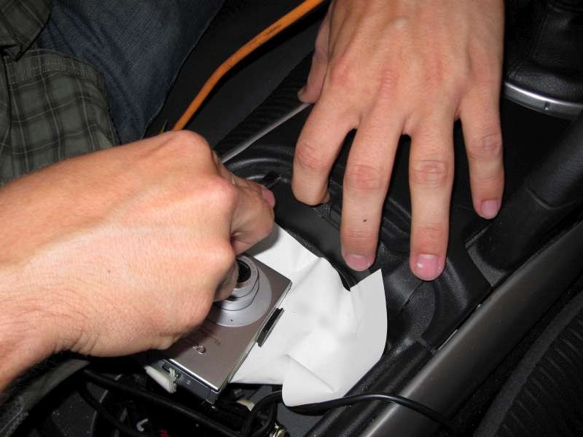  Loosen the center console by carefully wedging a flat screwdriver under the panel, and pulling it loose. It isn’t necessary to take off the shift knob. | 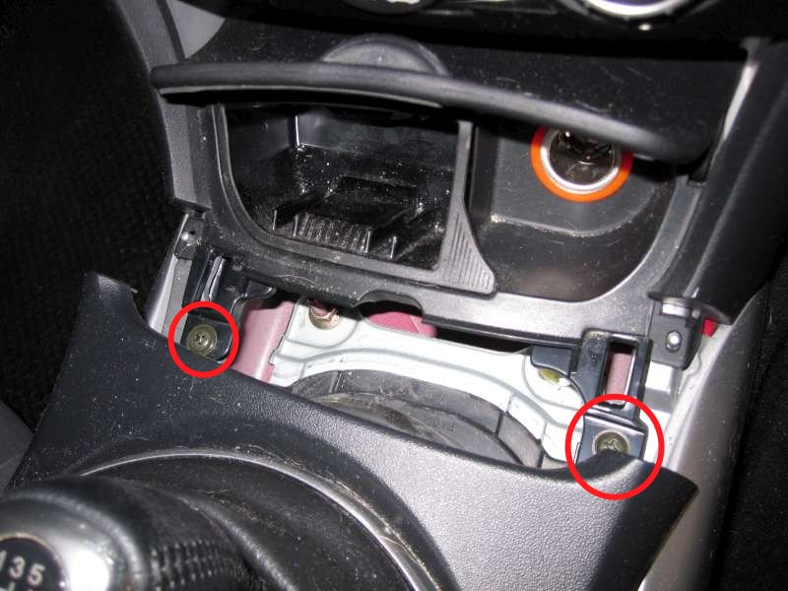  Remove screws and gently pull out the ashtray compartment. Be sure to unplug both connectors and unclip the ashtray light with needle-nose pliers.
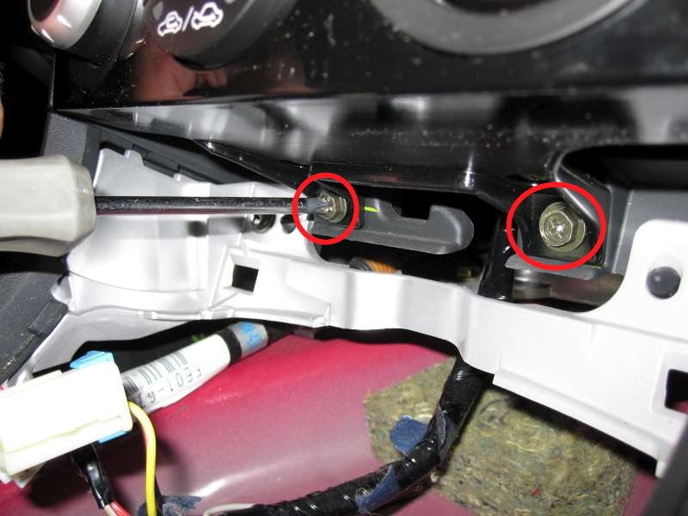  Remove the two screws holding in the bottom of the head unit. Also remove the 10mm “mystery bolt” on the left side of the head unit. Access this bolt from the driver side foot well, behind the plastic trim. | 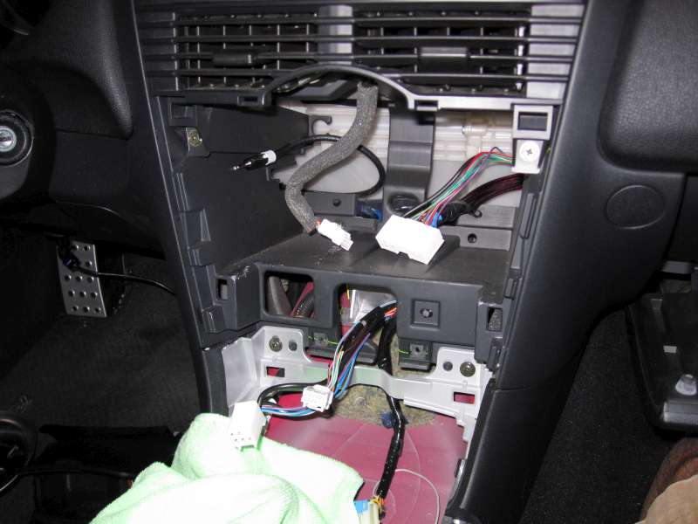  Disconnect the 2 HVAC connectors behind the HVAC controls, the head unit’s harness, the LCD harness, the FM antenna and any CD/Sirius/iPod adapters. Remove the head unit from the car. It is a good idea to cover the shift knob with a piece of cloth to protect the face plate from scratches.
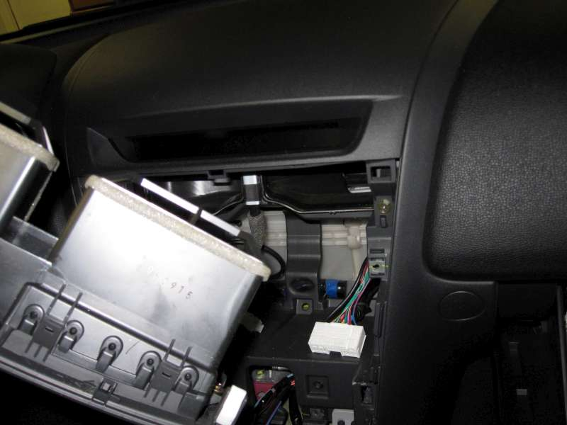Remove the two screws holding the air duct in and remove the air duct module from the car. | 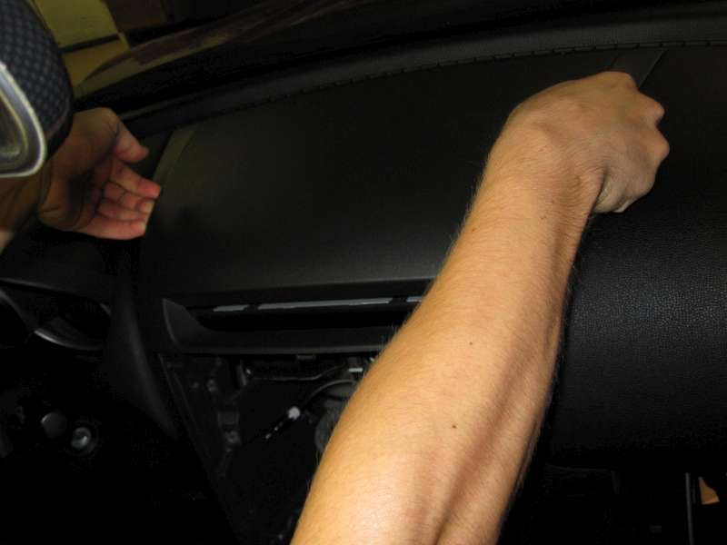Remove the two screws holding the dash cover on, and remove the dash cover from the car by gently prying it up so the clips pop free.
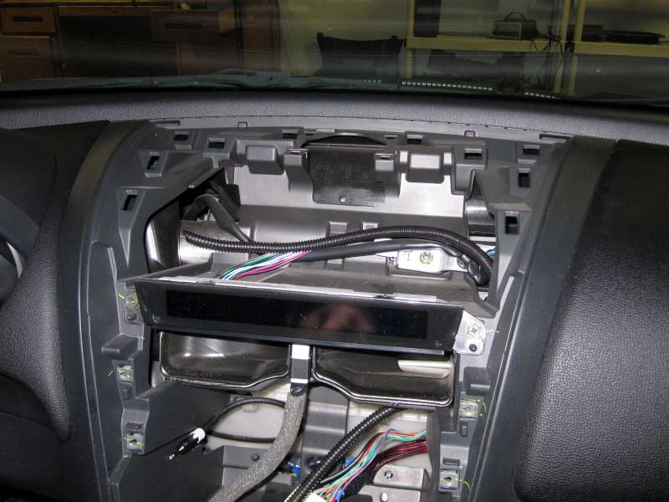Thread the GOODbox harness (connector first) down from the top of the dash through the opening on the right, behind the air ducts. | 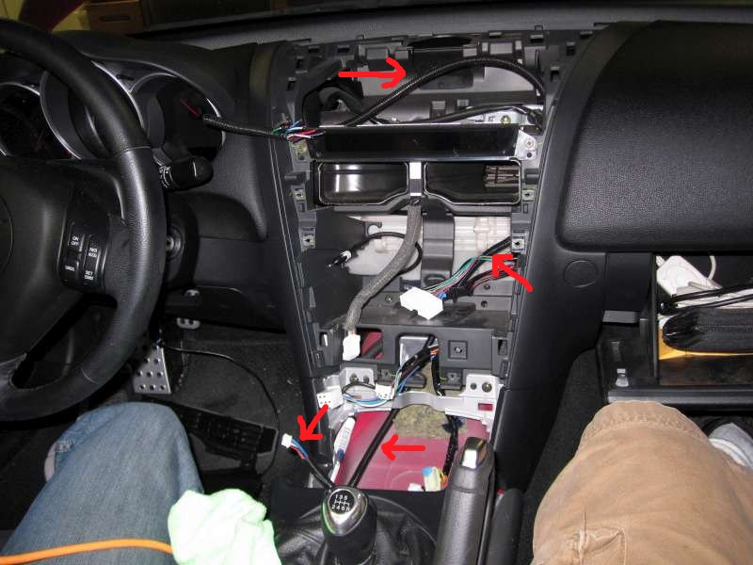  Finish threading the GOODbox harness down behind the head unit braces down to the ashtray connectors. Pull enough through to have some comfortable slack.

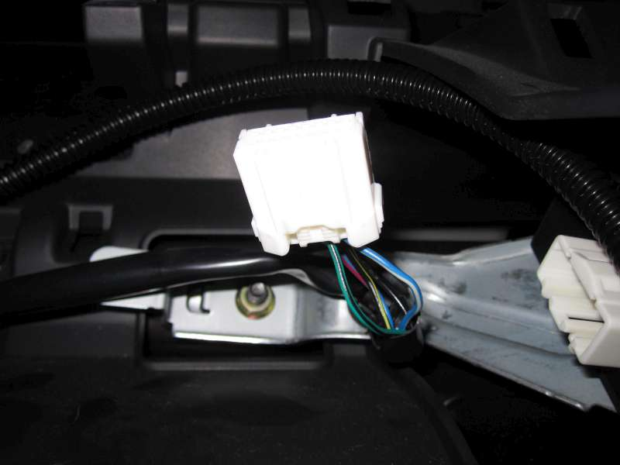  Locate and disconnect the Tire Pressure Sensor Module connector. It sits just under the dash cover on the right side, above the center air vents. Cut away about 2” of the harness sheathing. A hobby knife works well for this. |  | 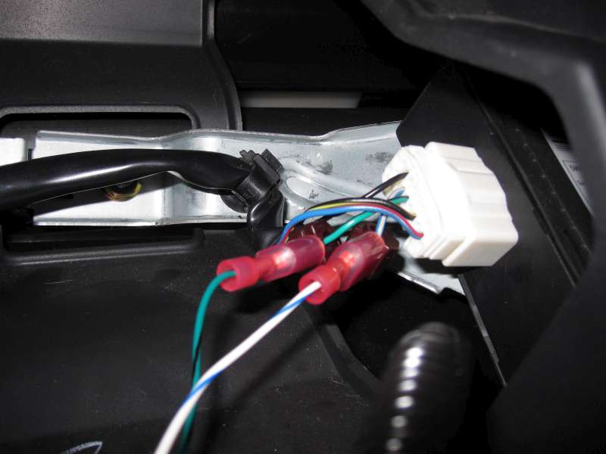Cut the blue/white and green/black wires in the GOODbox harness to length and splice them into the matching colored wires in the TPMS harness. This is the CAN bus. Plug the TPMS harness back in.
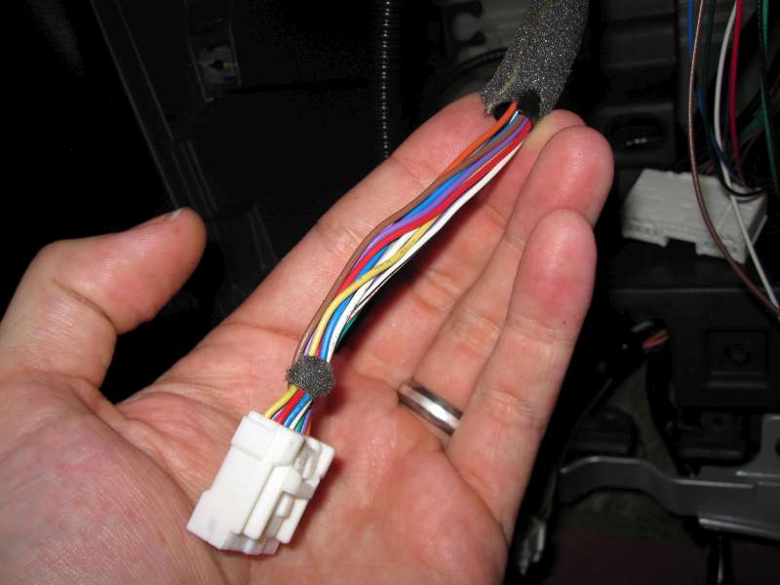Cut away about 4 inches of the harness that comes from the display module. | 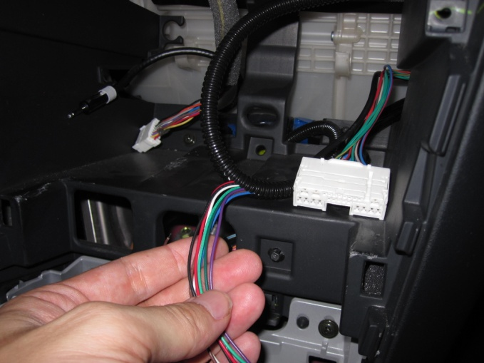  Pull the White, Brown, Blue, Purple, Light Green and Dark Green wire out of the GOODbox harness and cut them to comfortably reach the display harness. Keep in mind the position of the harnesses when the Head Unit is re-installed.
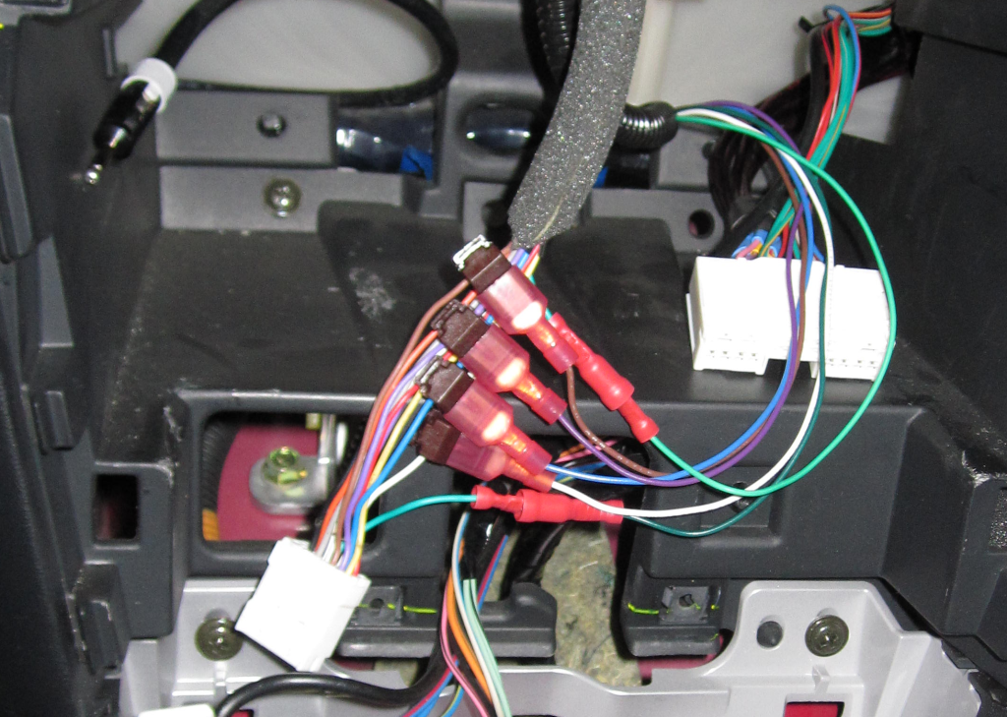
Splice the White, Brown, Blue and Purple wires out of the GOODbox harness into the display harness by matching the colors. Cut the Green wire in the display harness in the middle and connect the Light Green wire from the GOODbox harness to the LCD side, and the Dark Green wire to the Head unit side. It is recommended to use male/female bullet- or spade-style connectors so that you may return the car to stock by simply reconnecting the cut green wire.
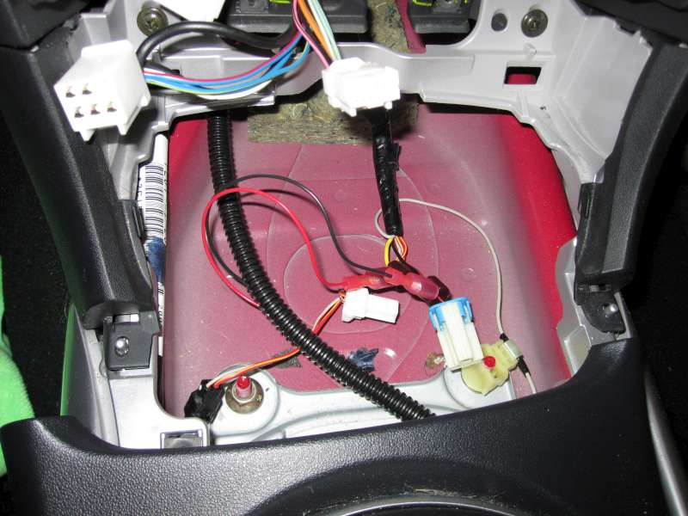Pull the Red and Black wires out of the GOODbox harness near the ashtray, cut them to length, and splice them into the cigarette lighter connector (the largest one). | 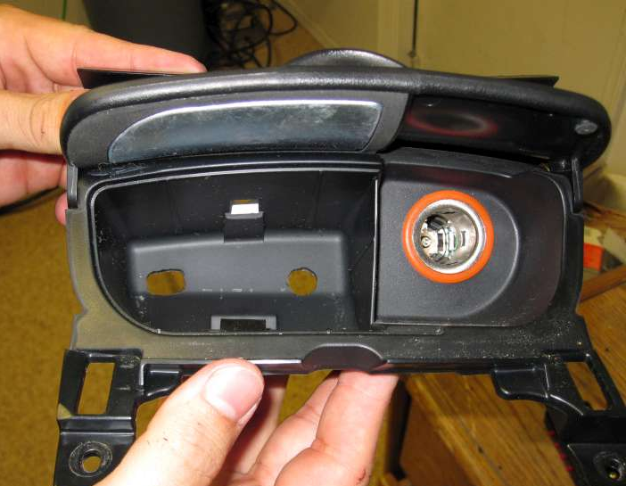Using a suitable cutting tool, cut holes into the back of the ashtray large enough for the GOODbox harness & connector, and optionally for a vacuum line.
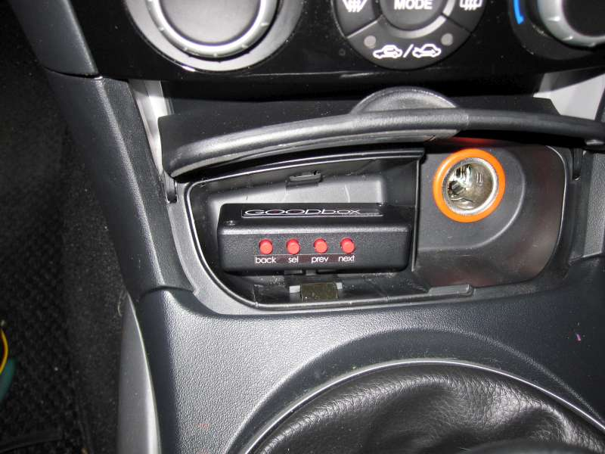In this order, replace the dash cover, HVAC duct module, Head Unit, ash tray module and center console panel. Be sure to pull the GOODbox harness and optional vacuum line through the holes in the ash tray before screwing it down. Connect the GOODbox harness to the GOODbox. | 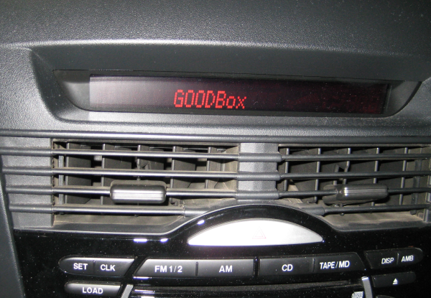  If everything was wired in correctly, you should see the startup text “GOODbox” when the ignition is turned to the ON position (not Accessory).

Operation manual

The GOODbox is allows you to choose from 4 customizable gauges screens. Each screen can display 1 or 2 gauges at a time, so you can quickly view up to 8 gauges. These screens are labeled A, B, C and D.

The GOODbox has 4 buttons. From left to right they are: BACK, SELECT, PREVIOUS and NEXT. It operates in three distinct modes: OFF, ON, MENU:
- When OFF, the display will work as normal and indicate radio station, CD track number, volume, etc.
  - Press SELECT to turn the GOODbox on.
- When ON, the GOODBox will take control of the 12 characters in the display and display the preconfigured gauges.
  - Press PREVIOUS to go the previous gauge screen.
  - Press NEXT to go the next gauge screen.
  - Press BACK to turn the GOODbox off.
  - Press SELECT to enter the menu mode.
- When in MENU mode, you can configure the features of the GOODBox.
  - Use PREVIOUS and NEXT to choose a menu item, or to change the value when the selected menu item is flashing.
  - Use SELECT to activate a menu item or sub-menu. When editing text, use this button to cycle through the characters.
  - Use BACK to return to the previous screen. Any changes made will be automatically saved.
Notes:
- The GOODBox will remember if it was on or off, and which gauge screen was active when the car was last turned off. When the car is started, it will resume accordingly. This way you never have to turn it on manually if you wish to always leave it on.
- The GOODBox will not do anything when the car’s ignition is turned to Accessory, the car has to be on for the GOODbox to function. If the engine is not running, some of the gauges might display meaningless data.
- If you remove the GOODbox from the car without reconnecting the green wire that was cut during installation, the display will flicker and look corrupted. If you have to remove the GOODbox but cannot reconnect the green wire, you can short the light and dark green wires at the connector with a thin wire. Be sure you don’t short anything else!
- Gauges are read approximately 4 times per second, so the GOODbox should not interfere with any data logging devices you might be using.

The available menu choices are:
- Gauges X (where X is A, B, C or D). Configure the indicated gauge screen.
  - Display Mode. Choose between dual or single display. Dual display will show a compact version of two gauges using 6 characters each. Single display with use all 12 characters for a gauge and typically is easier to read at a glance.
  - 1st or 2nd Guage: This menu item lets you choose what gauge you want as your first and second gauge for this screen. Note that when doing Single display, only the 1st gauge will be shown. The available gauges are:
    - Boost pressure. You will need to run a vacuum line to the GOODbox if you wish to use this gague.
    - Coolant temperature
    - Air/fuel ratio
    - Intake air temperature
    - Calculated engine load
    - Short term fuel trim
    - Long term fuel trim
    - Mass air flow
    - Throttle position
    - Engine RPM
    - Speed
    - Fuel system status (open or closed loop).
    - Absolute engine load
    - ECU commanded air/fuel ratio
    - Analog Aux 1/2 (see section on analog inputs for details)
- Aux 1/2 Setup. Setup for the analog inputs. See the section on Analog Input for more details.
- Boost Config. Configuration options for the Boost gauge.
  - Set 0 boost. Selecting this will calibrate the boost gauge. Be sure to this with the engine off or with the vacuum line disconnected. The GOODbox will record the current pressure as 0. You may wish to zero the boost anytime you take your car to different altitude to ensure an accurate measurement.
  - Danger Zone. This lets you choose the boost pressure at which the GOODbox will beep indicating a possible over-boost situation.
- Startup Text. Options for setting a custom startup text to replace the factory text.
  - Text on/off. Lets you enabled or disable the custom text.
  - Edit text. Lets you select the letters you want. Pressing SELECT will move to the next character, and pressing PREVIOUS or NEXT will cycle through the lower case and upper case alphabet, some symbols and the numbers. The selected character will blink. Note that if the selected character is a space, you will not see anything blinking.
- Setup Units. Choose units of measurement.
  - Temperature. Select between Celsius and Fahrenheit.
  - Speed. Select between MPH and KPH.
- View DTCs. Selecting this will let you view any Diagnostic Trouble Codes stored in the ECU. A maximum of 10 codes can be viewed.
- Clear DTCs. Erases all stored DTCs.

Custom Analog inputs
For specialized applications, there are 2 analog inputs that can be used to create custom calibrated gauges from after-market sensors. The input signal should be 0-5V. The logic board contains a simple 1KΩ/0.1μF lowpass filter to smooth the measurement. To connect a sensor wire to the GOODbox, some minor soldering is required. Open the GOODbox by removing the two screws and solder your sensor’s signal wire to one of the two analog pads indicated in the picture below. To route the wire out GOODbox, either cut a notch or drill a hole in the enclosure or feed it out though the vacuum line hole.

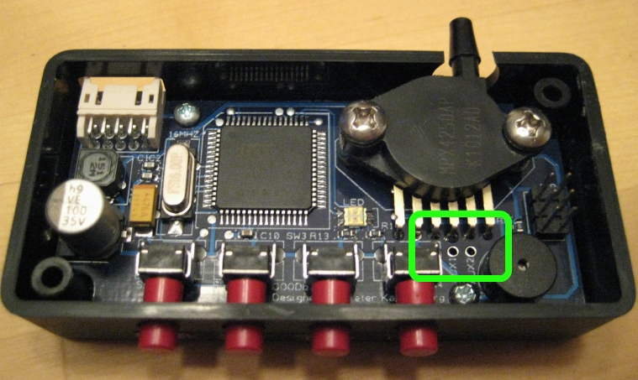

The GOODbox will read the voltage by converting it to a number between 0 and 1023 (10-bit analog-to-digital converter). It will then multiply that value by a number you choose, divide the result by 1000, and finally add an offset you also choose. This lets you apply any linear scale to the sensor readout. In formula:
FinalValue = RawValue * Multiplier/1000 + Offset

You can then choose how to display the computed value by editing the format and text. A format and text look something like this:
Format: xxxxxx000.0u
Text: OilTmpTRASHF

When the gauge is active, the x’s and u’s get replaced by the letters in the Text, and the measured value gets placed where the 0’s are. Using the example above, if the computed value was 1234, the final gauge would show OilTmp123.4F. When choosing format and text, you should provide both the short and long format for dual and single display. They are 6 and 12 characters respectively.

Configure your custom gauge or gauges by entering the GOODbox menu and selecting the Aux 1 Config or Aux 2 Config option. Then the following menu items are available:
- Show raw value: This will display the sensor readout as the GOODbox sees it. This is a number that ranges from 0 to 1023 as the sensor goes from 0V to 5V. Use this value to characterize your sensor. Make a table of the known values against the raw value. For example, a raw value of 400 might correspond to 190F when using an oil temperature sensor.
- Multiplier. This lets you choose the multiplier to scale the raw value with. The valid range is from −32,768 to +32,767.
- Offset. This lets you choose the constant offset. The valid range is from −32,768 to +32,767.
- Full Format. Lets you choose the format for the custom gauge when used in Single display mode. Use SELECT to cycle between the x’s, 0’s, location of the decimal, and u’s. Use PREVIOUS and NEXT to adjust each part of the format.
- Full Text. Choose the letters that you want to use for your custom gauge in single display mode. Note that only the letters that match up with the positions of x’s or u’s in the format will show on the gauge. This works the same way as editing the Startup Text.
- Short Format. Lets you choose the format for the custom gauge when used in dual display mode. Use SELECT to cycle between the x’s, 0’s, location of the decimal, and u’s. Use PREVIOUS and NEXT to adjust each part of the format.
- Short Text. Choose the letters that you want to use for your custom gauge in dual display mode. Note that only the letters that match up with the positions of x’s or u’s in the format will show on the gauge. This works the same way as editing the Startup Text.

